Eventi
Use Case Specification

Submitted to:

Asst. Prof. Ma. Rowena C. Solamo
Faculty Member
Department of Computer Science
College of Engineering
University of the Philippines, Diliman

Submitted by:
Dimaano, Aaron Diego I.
Lopez, Matthew S.
Torres, Jacob Angelo V.

In partial fulfillment of academic requirements
for the course
CS 191 Software Engineering I
of the
1st Semester, AY 2015-2016
Unique Reference:
The documents are stored in https://github.com/Tom-2013-06417/CS191-192_Event_Sharing/tree/master/02-Requirements%20Engineering.
Link to this document:

Document Purpose:
The purpose of this document is to exhaust the step-by-step process of the Use Cases in every scenario possible.

Target Audience:
To our project client and adviser, our fellow 191 classmates, and our future selves when they need to refer back to this document.

Revision Control:

Revision Date | Person Responsible | Version  Number | Modification
09/18/15 | Dimaano, Diego  Lopez, Matthew  Torres, Jacob | 1.0 | Initial Document

Use-Case Name: Manage own profile (Organization)

Description: Details change from time to time. By allowing people to update their organization’s data, we’re accommodating the idea that their organizations are developing and are continuing to do so. By keeping data up-to-date, viewers are granted access to all the relevant information they need.

Preconditions: There is an internet connection to the Eventi server and a device with browsing capabilities. A registered user that has permission to operate an organization must be currently logged into the site.

Flow of Events:

Scenario Name | Description
Scenario 1 (Basic Flow)  Registered User passes valid information for updating the Organization’s details | 1. Registered User opens and chooses to edit the Organization’s profile  2. Registered User is prompted by the System to provide the updated information for the Organization  3. The System accepts the information provided by the Registered User  4. The Organization’s profile is then updated
Scenario 2  Registered User passes invalid information for updating the Organization’s details | 1. Registered User opens and chooses to edit the Organization’s profile  2. Registered User is prompted by the System to provide the updated information for the Organization  3. The System denies the information provided by the Registered User and asks the Registered User to input valid information  4. If the Registered User wants to continue updating the Organization’s information, they must input valid information  5. Once valid information has been provided, the Organization’s profile shall be updated
Scenario 3  Registered User cancels the update after passing invalid information | 1. Registered User opens and chooses to edit the Organization’s profile  2. Registered User is prompted by the System to provide the updated information for the Organization  3. The System denies the information provided by the Registered User and asks the Registered User to input valid information  4. If the Registered User wants to stop trying to update the Organization’s information, they can opt to cancel the update instead of providing valid information for the system

Activity Diagram of the Flow of Events:

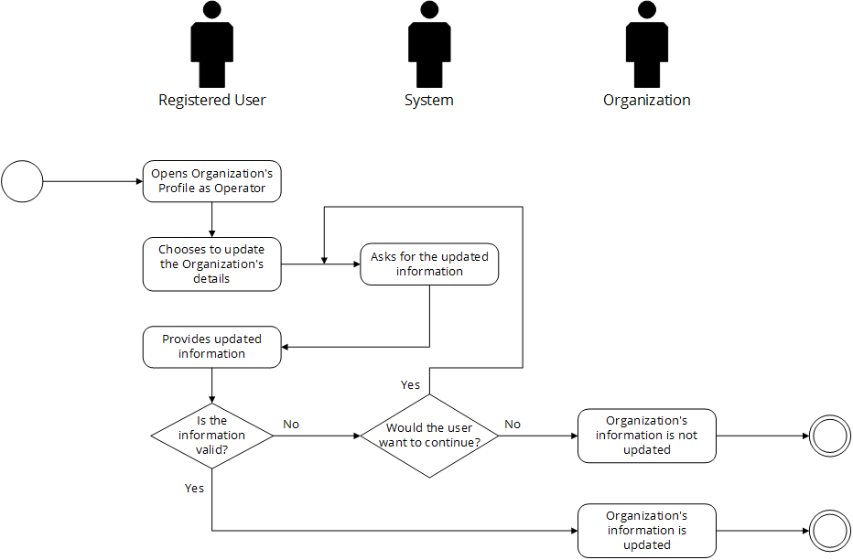

Post-conditions: Successful: The Eventi homepage has successfully loaded and the events are shown. The Organization’s information was updated
Failed: The website did not load. The Organization’s information wasn’t updated

Special Requirements: NONE

